#1  39 Brook Rd. |  |  | #6  30 Rand Pl.
#1  39 Brook Rd. |  |  | #6  30 Rand Pl.
#1  39 Brook Rd. |  |  | #6  30 Rand Pl.
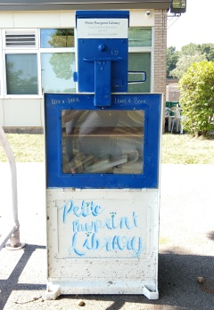  #7  Jefferson Rd Elementary School |  |  | This Adventure Belongs To:  ______________________________  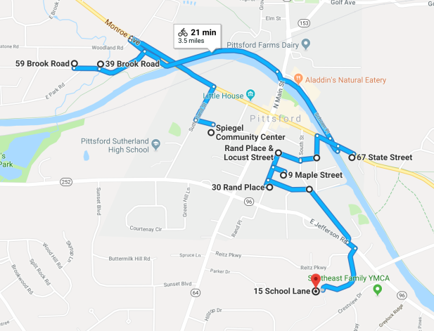
#7  Jefferson Rd Elementary School |  |  | This Adventure Belongs To:  ______________________________
#7  Jefferson Rd Elementary School |  |  | This Adventure Belongs To:  ______________________________
#3  67 State St. |  |  | #4  Pittsford Nursery School
#3  67 State St. |  |  | #4  Pittsford Nursery School
#3  67 State St. |  |  | #4  Pittsford Nursery School
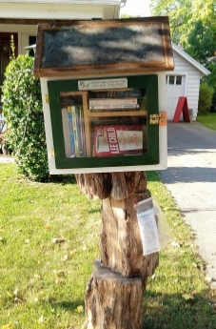  #5  9 Maple St. |  |  | #2  59 Brook Rd.
#5  9 Maple St. |  |  | #2  59 Brook Rd.
#5  9 Maple St. |  |  | #2  59 Brook Rd.

